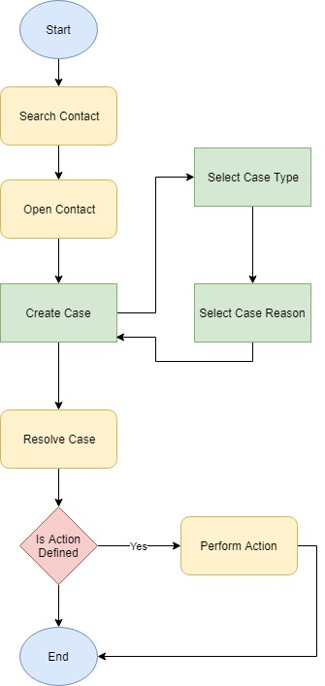

|  |  |  |
| --- | --- | --- |
| **Case Type** | **Case Reason** | **Action** |
| Enquiry | Information | NA |
| Problem | Technical | NA |
| Service Request | Start Service | Contact:Start Service Activate all deactivated payments on and after today |
| Service Request | Stop Service | Contact:Stop Service Deactivate all activated payments on and after today |
| Service Request | Add-On Service | TBD |
| Service Request | Plan Change | TBD |
| Service Request | New Lead | Create new Lead with information provided |
| Problem | Billing Related | NA |